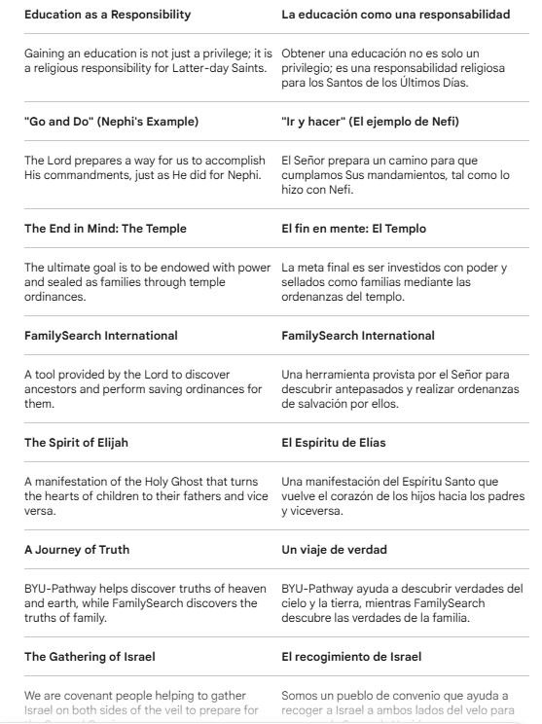

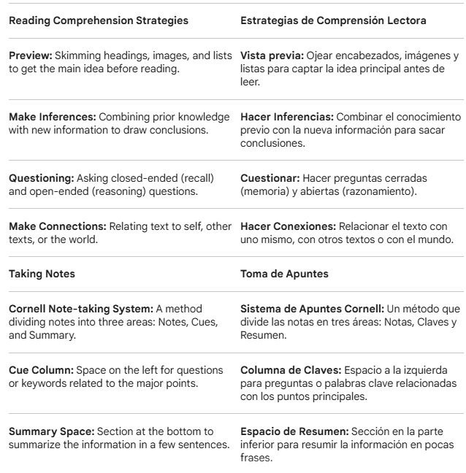

PRAYER:
Our Dear Heavenly Father,
We come before Thee this day with hearts full of gratitude for the blessings Thou pourest out upon us. We deeply thank Thee for the opportunity to progress through education and for the BYU-Pathway Worldwide program, which allows us to develop our talents and fulfill our responsibility to learn.
We ask that Thy Spirit may be with us as we put our study skills into practice. Help us to have clarity as we read, to be diligent in our note-taking, and to be like Nephi, having the faith to 'go and do' that which Thou hast commanded us.
Father, we thank Thee in a special way for the Spirit of Elijah. Please bless our efforts as we use FamilySearch to find our ancestors. Grant that our hearts may turn to them and that we may be instruments in Thy hands to unite our families for eternity through the ordinances of Thy Holy House.
Strengthen us to be a covenant people who help in the gathering of Israel on both sides of the veil. We place our lives in Thy hands and ask for these blessings in the name of Thy Son, Jesus Christ. Amen."

